<Autism Support Companion (MobileAPP)>
Software Requirements Specification

Version 1.0



Group Id: <S240290598>
Supervisor Name :< Abdullah Qamar>

Revision History
Date (dd/mm/yyyy) | Version | Description | Author
20/05/2024 | 1.0 | The Autism Support Companion App is a cutting-edge mobile solution designed to empower individuals on the autism spectrum, their caregivers, and therapists. By providing a comprehensive suite of features, the app aims to enhance daily living, communication, emotional intelligence, and social skills. Key functionalities include personalized task management, emotional regulation tools, and innovative communication aids, all integrated within a user-centric and intuitive interface. By harnessing the power of technology, this app seeks to bridge the gap between individuals with autism and their support networks, fostering greater independence, confidence, and overall well-being. | Bc200407858
Date (dd/mm/yyyy) | Version | Description | Author
 | 1.1 | Software requirement and specification is a document that describes what the software will do and how it is expected to perform. It also describe the functionality system needs to fulfill user needs.  In SRS we included :  Scope of project, functional requirement , non-functional requirement, use case diagram , usage scenario, adopted methodology and work plan. | Bc200407858

Table of Contents

- Scope (of the project)
- Functional Requirements Non Functional requirements
- Use Case Diagram
- Usage Scenarios
- Adopted Methodology
- Work Plan (Use MS word/Work Plan)
- Glossary
- Some basic details

SRS Document

Scope of Project:

<The Autism Support Companion App is a mobile application designed to provide a supportive digital tool for individuals on the autism spectrum, their caregivers, and therapists. The app aims to offer features and functionalities that assist in managing daily tasks, communication, emotional regulation, and social skills development.>

Functional and non Functional Requirements:

<Functional Requirements:
- User Registration:
  - Users can create an account by providing essential information (name, email, password, picture).
  - Consider the user did not register itself; parent or guardian can register on user's behalf.
- User Login:
  - Registered users can log in securely using their credentials.
  - Click on picture, icon, etc.
- User Profiles:
  - Users can create and update their profiles with relevant personal details.
  - Profile data should include preferences, sensitivities, and communication needs.
- Sensory Support:
  - Provide tools and resources to assist with sensory regulation, such as calming exercises and sensory-friendly content.
- Communication Tools:
  - Include features for augmentative and alternative communication (AAC) methods.
  - Offer customizable communication boards and visual supports.
- Task Management:
  - Implement task scheduling and reminders to aid in daily routines and time management.
- Social Skills Training:
  - Offer interactive modules and activities for practicing social skills and emotional understanding.
  - Provide virtual scenarios for social interaction practice.
- Emotional Regulation:
  - Include techniques and exercises for managing emotions and stress.
- Accessibility:
  - Design the app with accessibility features for users with diverse needs.
  - Provide options for font size adjustment, color contrast, and text-to-speech capabilities.
Non-Functional Requirements:
- Interface:
  - The system will have a user-friendly interface.
- Usability:
  - The system will be easy to use for users with diverse needs.
- Maintainability:
  - The system should be built in such a way that classification of errors and maintenance of mechanisms becomes easy.
- Security:
  - The system will be secure, and no one can use the app without registration.
- Reliability:
  - The system will support 7x24 operations.
- Access:
  - The system will be accessible over the internet.
- Scalability:
  - The system will be able to handle an increasing number of users.
- Availability:
  - The system will be available 99.99% of the time.
- Capacity:
  - The system will be able to handle a large amount of data.
- Performance:
  - The system will respond quickly to user interactions.
>

Use Case Diagram(s):

<+----------------------------------------------------+
| Autism Support App |
+----------------------------------------------------+
| Use Cases |
+----------------------------------------------------+
| User Registration and Login <-------------------> User, Caregiver
| (register on behalf of user) |
+----------------------------------------------------+
| Manage User Profile <-------------------> User, Caregiver
| (update profile, preferences, |
| sensitivities, and communication needs) |
+----------------------------------------------------+
| Access Sensory Support <-------------------> User
| (calming exercises, sensory-friendly content) |
+----------------------------------------------------+
| Use Communication Tools <-------------------> User
| (AAC methods, customizable boards, visual supports) |
+----------------------------------------------------+
| Manage Tasks <-------------------> User, Caregiver
| (task scheduling, reminders, daily routines) |
+----------------------------------------------------+
| Social Skills Training <-------------------> User
| (interactive modules, virtual scenarios) |
+----------------------------------------------------+
| Emotional Regulation <-------------------> User
| (techniques and exercises for managing emotions) |
+----------------------------------------------------+
| Accessibility Features <-------------------> User, Caregiver
| (font size adjustment, color contrast, text-to-speech) |
+----------------------------------------------------+
| Track Progress <-------------------> Caregiver
| (monitor user's progress and performance) |
+----------------------------------------------------+
| Generate Reports <-------------------> Caregiver
| (generate reports on user's progress and performance) |
+----------------------------------------------------+
| Actors |
+----------------------------------------------------+
| User Caregiver Therapist System Admin |
+----------------------------------------------------+The diagram shows the various functionalities of the Autism Support Companion App, including user registration and login, profile management, sensory support, communication tools, task management, social skills training, emotional regulation, accessibility features, progress tracking, and report generation.
The actors involved in the app are the User, Caregiver, Therapist, and System Admin, each interacting with specific use cases to achieve their goals. This diagram provides a comprehensive overview of the app's functionality and interactions, making it easier to understand and develop the Autism Support Companion App.
>

Usage Scenarios:

Here are some usage scenarios for the Autism Support Companion mobile app:
Scenario 1: User Registration
- The user downloads and installs the app.
- The user creates an account by providing essential information (name, email, password, picture).
- The user logs in to the app using their credentials.
Scenario 2: Daily Task Management
- The user logs in to the app and accesses the task management feature.
- The user creates and schedules tasks for the day.
- The app sends reminders and notifications to the user to complete tasks.
Scenario 3: Sensory Regulation
- The user logs in to the app and accesses the sensory support feature.
- The user selects a calming exercise or sensory-friendly content.
- The app provides the selected content to the user.
Scenario 4: Social Skills Training
- The user logs in to the app and accesses the social skills training feature.
- The user selects an interactive module or activity.
- The app provides the selected module or activity to the user.

Adopted Methodology:
The VU Process Model will be used for this project, which is a combination of the Waterfall and Spiral models. This model allows for risk management at regular stages in the entire software development cycle.
Waterfall Methodology:

The Waterfall Model was the first Process Model to be introduced. It is also referred to as a linear-sequential life cycle model. It is very simple to understand and use. In a waterfall model, each phase must be completed before the next phase can begin and there is no overlapping in the phases. The Waterfall model is the earliest SDLC approach that was used for software development.

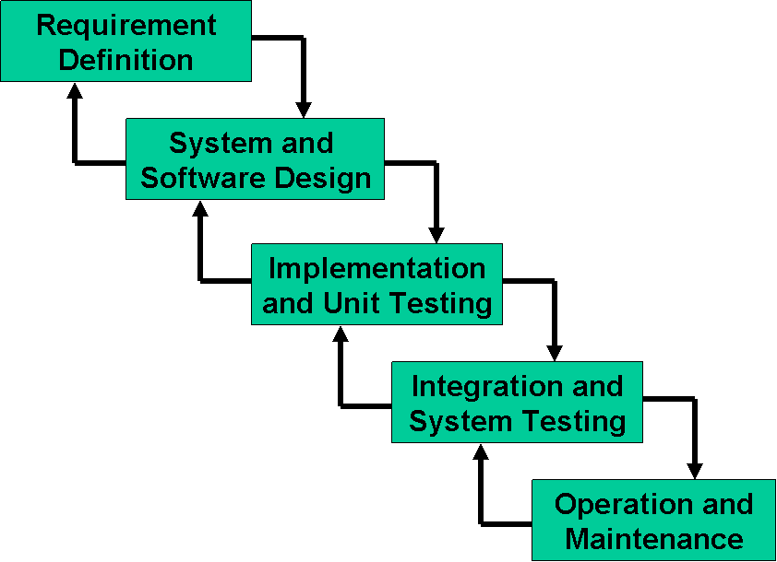

The phases for waterfall methodology are :
- Requirement definition
- System and software design
- Implementation and unit testing
- Integration and system testing
- Operation and maintenance

Spiral Model:

Spiral Model is a combination of a waterfall model and iterative model. Each phase in spiral model begins with a design goal and ends with the client reviewing the progress. . The main idea of this model is to avert risk as there is always an element of risk in development of software. For example, key personnel may resign at a critical juncture, the manufacturer of the software development may go bankrupt, etc. As can be seen, a Spiral Model has two dimensions. Radial dimension represents the cumulative cost to date and the angular dimension represents the progress through the spiral.

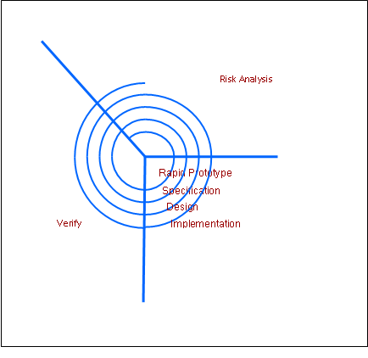

VU Process Model:
I am choosing VU process model. The reason for choosing this model is because this model is combination of waterfall and spiral model. And to get benefit of both model. In waterfall model we go for series of phases starting with system requirement leading to maintenance. And key characteristics of spiral model is risk management at regular stages in the entire software development cycle.

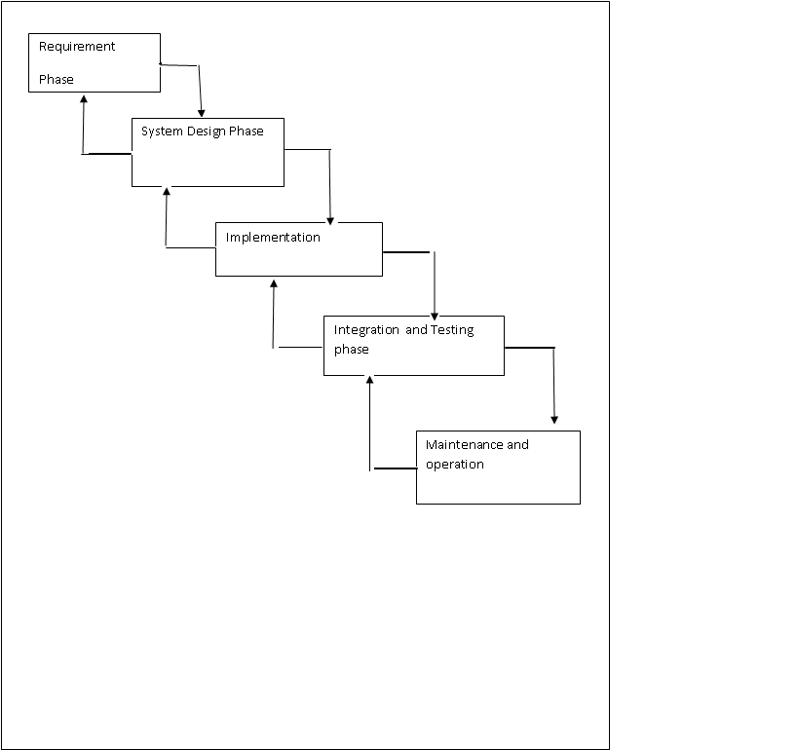

Work Plan (Use MS Project to create Schedule/Work Plan):

Task | Duration | Start | Finish | Predecessors | Resource Names
SRS | 10 days | 7/1/2024 | 7/10/2024
Scope of project | 3 days | 7/1/2024 | 7/3/2024
Functional Requirement | 7 days | 7/11/2024 | 7/19/2024 | 1, 2
Non-Functional Requirement | 7 days | 7/11/2024 | 7/19/2024
Use case diagram | 3 days | 7/22/2024 | 7/24/2024 | 3, 4
Usage Scenario | 4 days | 7/25/2024 | 7/30/2024 | 5
Adopted Methodology | 1 day | 7/10/2024 | 7/10/2024
Work Plan | 2 days | 7/31/2024 | 8/1/2024 | 6
Design Document | 20 days | 8/2/2024 | 8/29/2024
Test Phase | 10 days | 8/30/2024 | 9/12/2024 | 9
Final Deliverable | 1 day | 9/13/2024 | 9/13/2024 | 10

Glossary:
- AAC: Augmentative and Alternative Communication
- API: Application Programming Interface

SOME BASIC DETAILS

Purpose

The purpose of this SRS document is to outline the requirements for the Autism Support Companion App. This app is designed to assist individuals on the autism spectrum, their caregivers, and therapists by providing tools for managing daily tasks, communication, emotional regulation, and social skills development.

Definitions, Acronyms, and Abbreviations

AAC: Augmentative and Alternative Communication
App: Application
SRS: Software Requirements Specification

References

Android Developer Documentation
Flutter Documentation
UX Design Principles for Accessibility

Product Perspective

The Autism Support Companion App will be developed as a mobile application for the Android platform. It will be designed to provide comprehensive support for individuals with autism, their caregivers, and therapists.

Product Functions

User Registration and Login
Profile Management
Sensory Support Tools
Communication Tools
Task Management
Social Skills Training
Emotional Regulation Techniques
Accessibility Features

User Classes and Characteristics

Individuals with Autism: Users who will benefit from the app’s features for daily management and skill development.
Caregivers/Parents: Individuals who will manage and monitor the app's usage for those with autism.
Therapists: Professionals who will use the app to support their therapy sessions and track progress.

Operating Environment

The app will be developed for the Android platform.
Development tools include Android Studio and Flutter.
A cloud database will be used for storing user data.

